**CP Club 365Days Challenge**

**Programming language – Python**

**Problem Statement**

https://practice.geeksforgeeks.org/problems/burst-balloons/1

**Your Code**:

# 0x67Day of 0x365Days challenge

# VEDANT BHARAD

# 23-12-2022

from typing import List

class Solution:

    def maxCoins(self, N : int, arr : List[int]) -> int:

        # code here

        tempArr = [[0 for loop in range(N + 2)] for loop in range(N + 2)]

        arr.append(1)

        arr.insert(0,1)

        ans=0

        for loop in range(N, 0, -1):

            for loop2 in range(loop, N + 1):

                ans = 0

                for loop3 in range(loop, loop2 + 1):

                    tempsum = arr[loop-1]*arr[loop3] *arr[loop2+1]+tempArr[loop][loop3-1]+tempArr[loop3+1][loop2]

                    ans = max(ans, tempsum)

                tempArr[loop][loop2] = ans

        return ans

#{

 # Driver Code Starts

class IntArray:

    def __init__(self) -> None:

        pass

    def Input(self,n):

        arr=[int(loop) for loop in input().strip().split()]#array input

        return arr

    def Print(self,arr):

        for loop in arr:

            print(loop,end=" ")

        print()

if __name__=="__main__":

    t = int(input())

    for _ in range(t):

        N = int(input())

        arr=IntArray().Input(N)

        obj = Solution()

        res = obj.maxCoins(N, arr)

        print(res)

# } Driver Code Ends

**Output (Screen Shot)**:

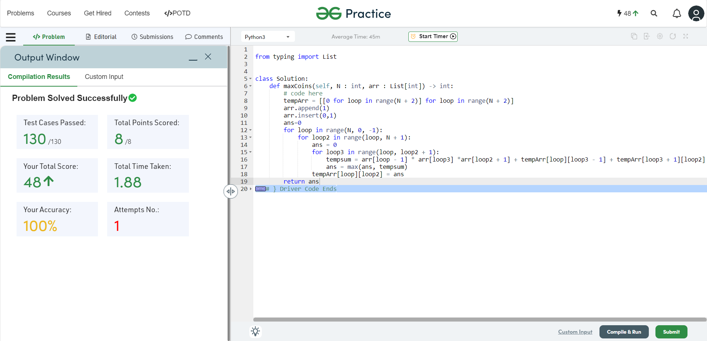

**Understanding about problem:**

This task is tricky In this task I need to find maximum coins from the array using a specific method.

Note: If you can't understand the problem, feel free to contact us and we'll help you. Please don't copy and paste from anywhere.

ALL THE BEST

Team CP Club